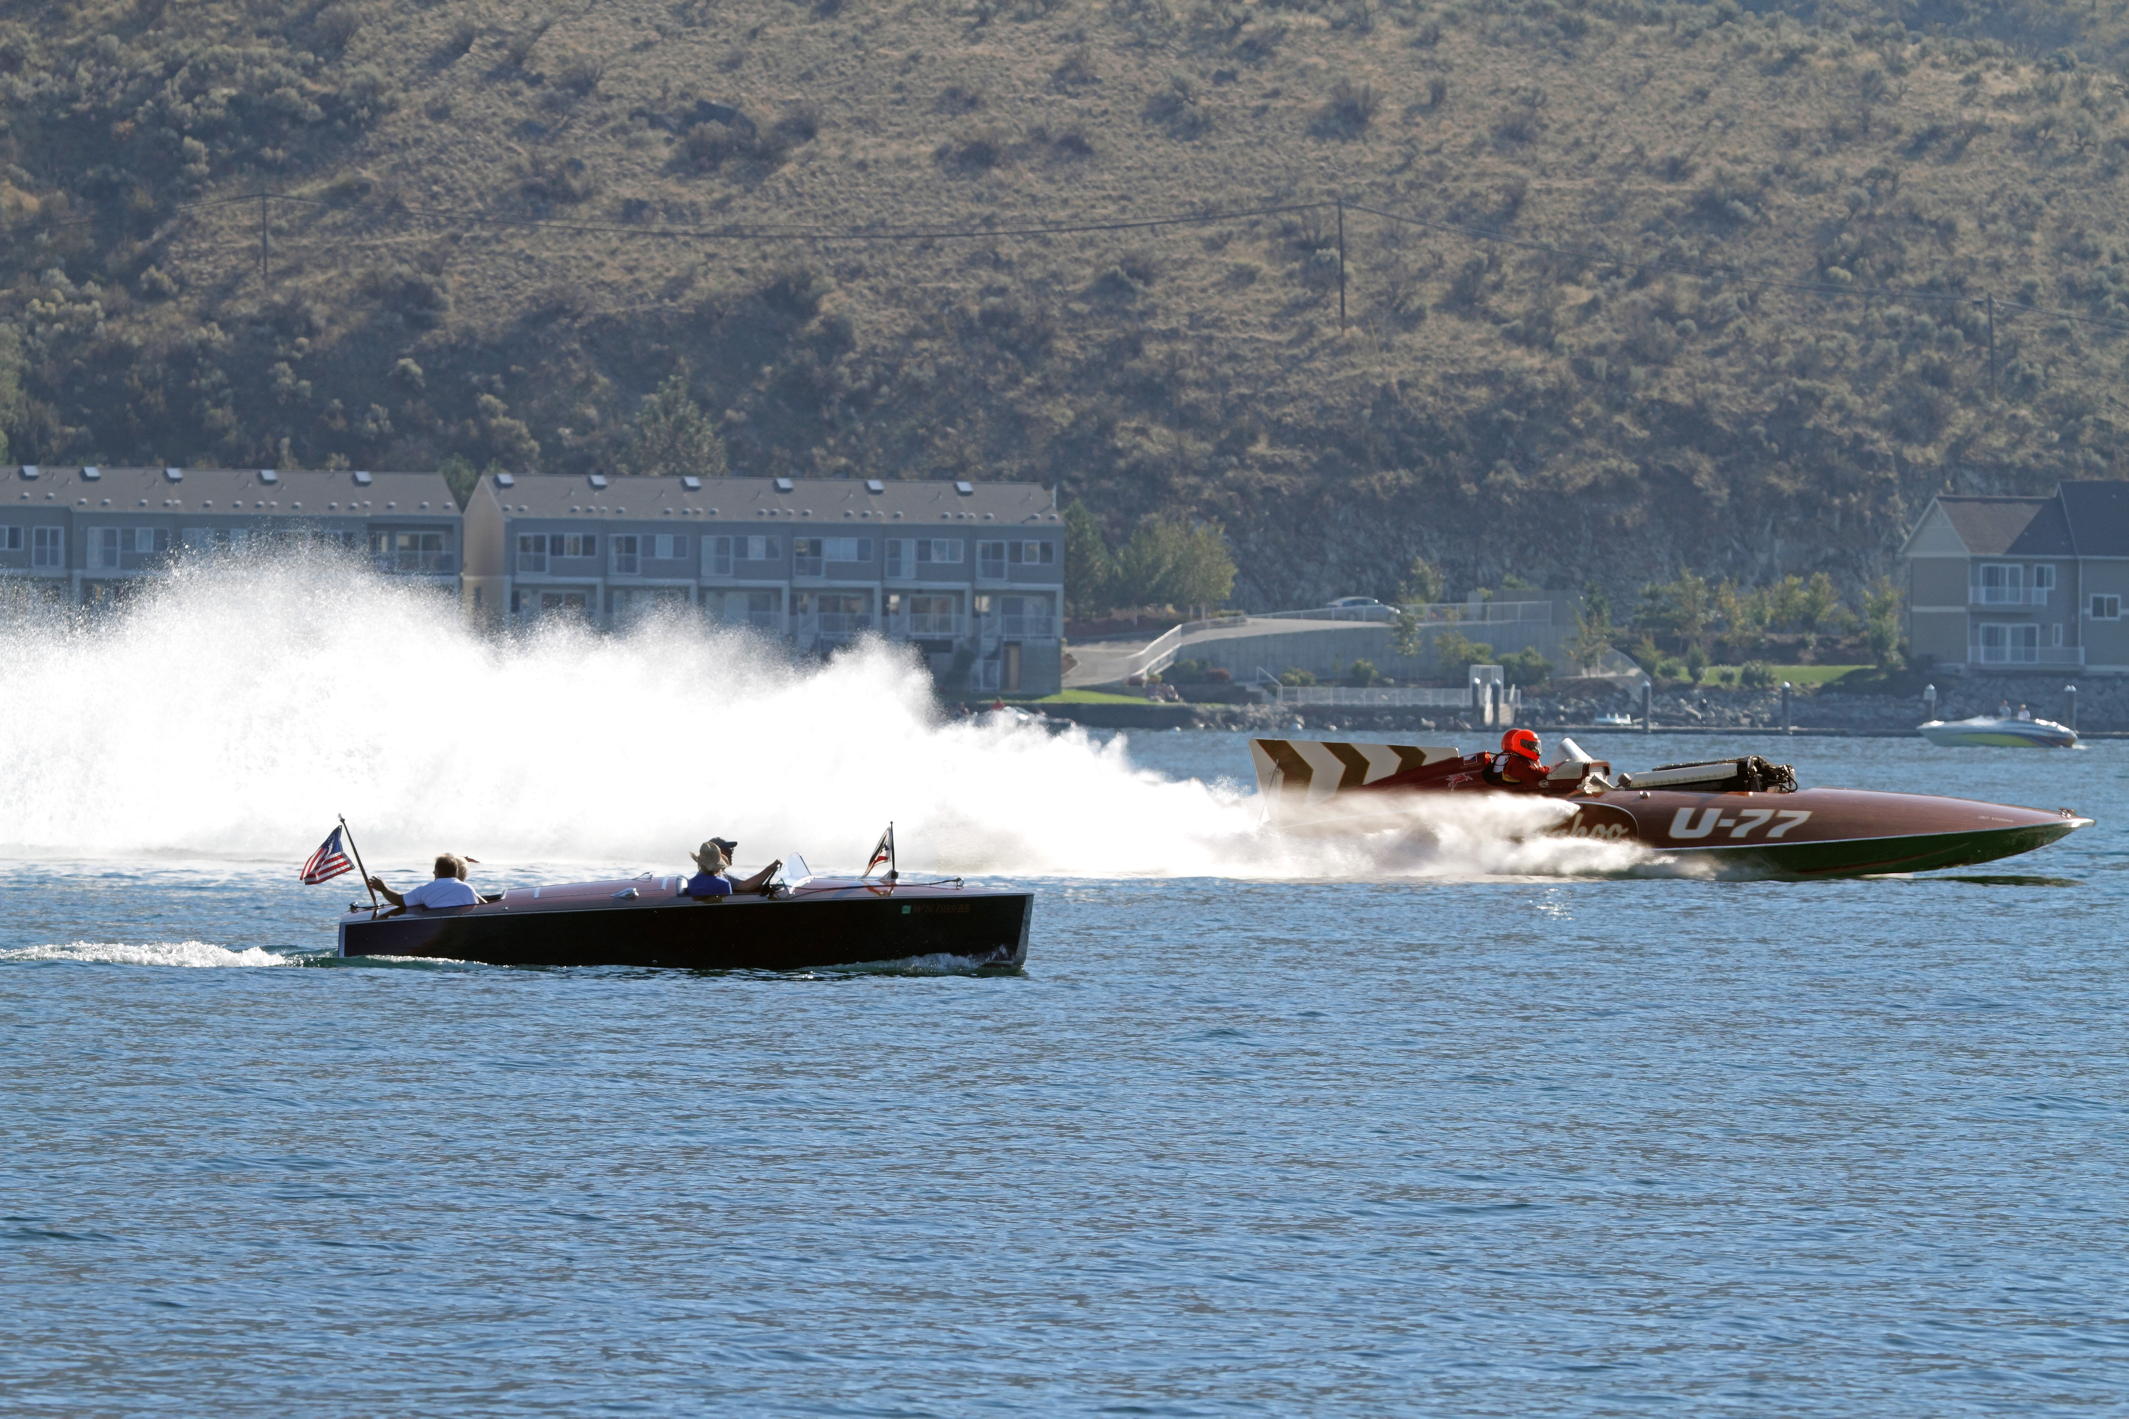
Mahogany & Merlot Sponsorship
October 7 & 8, 2017

Title Sponsorship
Level $10,000

Mahogany & Merlot sponsored by (Your Company’s Name Here)

Your benefits would be:
- Your company name always connected with Mahogany & Merlot in all applications
- Your marketing materials in every participant packet
- Company logo on event tee shirts.
- Logo inclusion on posters, banners and all print media including press releases
- 10’ x10’ booth space for marketing purposes
- Name included in all Press Releases
- Commercial played on PA system on site throughout the event weekend
- 20 x 20 hospitality space for private party or marketing VIP area – view property
- Link on our face book and Home page on our web page
- Title naming commercials on SunnyFM and on the live remote Saturday, October 1 and all other radio media advertising
- Banners hung throughout weekend (banner provided by sponsor)
- Inclusion on Banner on Parade entries for Mahogany and Merlot
Benefits for Mahogany & Merlot:
- Cash sponsorship
- Clout of having you as a sponsor

Mahogany & Merlot Sponsorship

Naming Sponsorship
Level $1,500 ea

Areas to Name Include:
Mahogany Row in Marina, Unlimited Hydro Heats, Classic Car Show, Beer/Wine Garden, Food Court, Vintage Hydro Heats, Information Center and Friday night activities.

Your benefits would be:
- Every reference to named area would include your company name. (IE: ACME Wine Garden)
- Your marketing materials in every participant packet
- Inclusion on the where to go/shop/visit listing for participants.
- Logo inclusion on posters, banners and all print media including press releases
- 10’ x10’ booth space
- Link on our web page
- Inclusion on our Facebook page
- Inclusion on all advertising on GLC
- Inclusion on Banner on Parade entries for Mahogany and Merlot
- Inclusion in commercials on SunnyFM and on the live remote Saturday, October 7th
- Banner hung throughout weekend (banner provided by sponsor)
Benefits for Mahogany & Merlot:
- Cash sponsorship
- Clout of having you as a sponsor
Associate Sponsorship
Level $500 ea
Your benefits would be:
- Inclusion on the where to go/shop/visit listing for participants.
- Logo inclusion on posters, banners and all print media including press releases
- 10’ x10’ booth space
- Link on our web page
- Inclusion on Banner on Parade entries for Mahogany and Merlot
- Inclusion on our Facebook page
- Inclusion on GLC commercials
- Banner hung throughout weekend (banner provided by sponsor)
Benefits for Mahogany & Merlot:
- Cash sponsorship
- Clout of having you as a sponsor
Please check out the event web site: mahgoanyandmerlot.com

About the beneficiary:
Proceeds from Mahogany & Merlot benefit the Hydroplane and Raceboat Museum (HARM), a registered 501(c)(3) nonprofit corporation.
The Hydroplane and Raceboat Museum is the nation's only public museum dedicated solely to powerboat racing. Formed in 1983, our Mission: is to inspire and motivate learning and achievement while honoring, celebrating and preserving the legacy of Unlimited Hydroplane racing. The museum features an incredible collection of vintage hydroplanes spanning seven decades, including boats that have won 17 Gold Cups.
The Hydroplane and Raceboat Museum is also the nation's primary resource for historical and educational information on hydroplane racing. Our extensive collection of books, magazines, race programs, newspaper, photos, trophies, and other memorabilia dates back to the turn of the last century. We have over 200 hours of rare, vintage racing films transferred to videotape, covering hydroplane racing for the 1940s to the present.
The stories of famous drivers are here as well. Legendary Bill Muncey, Ron Musson, Mira Slovak, "Wild" Bill Cantrell and other past drivers are featured, plus information on many of the top modern drivers, including Chip Hanauer.
In addition to great archives on the the history of hydroplanes, our museum is also a fully equipped boat restoration shop. Over the years, we have restored seven of the most famous Gold Cup and Harmsworth winners to full running condition. Most important, these great hulls have been restored by Museum members, people like you who loved the boats and simply could not see them fade away.
HARM also offers two excellent youth education programs - the Junior Hydro Program (J-Hydro) and Victory Education.
The Junior Hydro Program (J-Hydro), is for kids 9 to 16 years of age. Children learn traditional wooden boat building skills while building and rigging their own J-Hydro and race their boat in APBA sanctioned events. The Museum created this “kit boat” to make it affordable for children to learn and participate. The boats are built alongside their family members at our Museum facilities.
Victory Education presents fun, engaging engineering challenges that allow students to apply science knowledge in meaningful ways through the excitement of hydroplane racing, while meeting the Washington State standards for learning. In addition to introducing students to the excitement of engineering and STEM, the Victory Education Program fosters valuable cognitive skills such as critical thinking, collaboration, communication, creativity, flexibility, persistence, and learning from failure.

